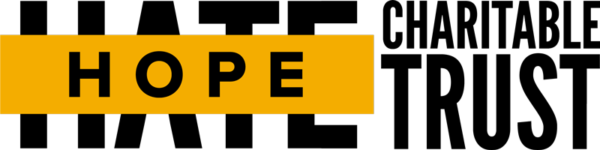

Mmm… Tasty Lesson Plan (KS2)
Learning Outcomes
- Understanding What prejudice is, and how it affects people.
- Evaluating the knock-on effects that even “low-level” discriminatory actions can have; especially around excluding minorities.
- Challenging the pupils to both reflect on their thoughts and also empowering them to stand up to others who show prejudicial behaviour.

Key Vocabulary
Discrimination; prejudice; challenge, bullying

Note
The parts of the lesson plan that are highlighted in RED are part of the ‘stretch and challenge’ aspects of the lesson. Please feel free to skip over these parts if you feel the child(ren) you are delivering to is too young or would be unable to follow.

Lesson Plan
Slides  2 - 5 | Activity:  Go through each slide (or print them off) with the different foods, getting the pupil(s) to decide if they would eat any of the chosen foods.  Slides are:  - Flower pizza  - Lychees (a fruit)  - Seasoned rotten eggs  - Seasoned maggots  Objective: to encourage debate and discussion with the pupil(s) and for the pupil(s) to feel comfortable being honest about their feelings and opinions, to ensure that the session can be as productive as possible. This should be a fun and upbeat activity.  At the end of the activity let the pupil(s) know that these are all considered specialities from different parts of the world and local people in these areas really enjoy the taste of each one and are willing to pay a lot of money for them.  - Flower pizza - London  - Lychees – South Pacific  - Seasoned rotten eggs - China  - Seasoned maggots - Asia  Ask: Why do some of us find them disgusting?
Slide 6 | Ask: What is prejudice?  [NOTE: this is a hard word to say. Say the word slowly (pre-ju-dice) to the pupil(s) and have them repeat it back to you to ensure they know how to sound the word]  Definition: Prejudice is an opinion that is not based on fact.  Prejudice is a natural part of our brains, it helped us makes quick decisions in primitive times to help stay alive. For instance, if a caveman saw a tiger they would automatically assume danger and run away, rather than making the risk to hang around to if it was really dangerous or friendly; as it might end up too late to run.  With the food we just looked at some of us made a prejudice. Our brains told us that the food was horrible only based on the look of the food. Our brains were trying to look out for us, as it thinks the food in the pictures might make us sick. This is annoying for the person who made the food, but helpful for you to be healthy.  However, the problem is that we not only use prejudice on food, but also humans. We often take one look at someone as quickly decided if they are good or bad.  Ask: Should we judge people on just looks?  No, we shouldn’t. In short, having a prejudice does not automatically make you a bad person – but we need to teach ourselves when we are being prejudicial and how we can deal with it.
Slide 7 | Ask: What is discrimination?  Definition: Discrimination is acting on prejudice  In summary, prejudice is what does on in your mind and discrimination is your actions based on those thoughts.
Analysis

The things we say and do all have consequences, we need to be carefully to think be for we speak.

Sometimes we can just dismiss what others have said as bad or wrong just because we do not fully understand their point of view. However, this does not make their opinions and less valued.

Ask: What can we do to stop ourselves accidently hurting others with our words?
Slide 8 | Activity: Pick Your Neighbour  Have the pupils work in small groups. Given them a paper and pencil and have them rank in order who they would like to live next door to them. Have the pupil(s) come up with reasons for their choices.  For those that put characters (1), (2) and (4) at the bottom, have a discussion as to why (but keep things friendly and non-critical).  The conclusion should be that we know very little about any of these people and have no idea just based on their looks if they are good or bad people.
Slide 9 | Discussion: What small changes can we take away from today?  We are not asking for revolutionary ideas, but realistic aims. The main focus should be for them to reflect on their own prejudice and behaviour and to empower them to stand up against prejudices.

